**Enterprise Resource Planning**

*Of*

**ZAB**

**Training User Manual**

**VERSION 12.0.0**

**Import LC**

**Index**

|  |  |
| --- | --- |
| **About** | **Page No.** |
| **Commercial Part** | |
| * Purchase Order (LC) | **03** |
| * Import LC Entry | **05** |
| * PO link with LC | **06** |
| * Document Retirement | **08** |
| **Account Part** | |
| * LC Opening Cost Entry | **09** |
| * Cost Payment & Payable Entry | **11** |
| **Inventory Part** | |
| * GRN Create From DCR | **17** |
| * GRN CONFIRM (LC) | **18** |

**Commercial Part**

# purchase ORDER (LC)

* Purchase Order Header

|  |  |
| --- | --- |
| **Step 1** | Main Menu (Home Icon) **> Commercial > Import LC >** PurchaseOrder(LC) |
| **Step 2** | Write PI Reference, Date, Supplier ID (), Store No. |
| **Step 3** | Choose Currency, Exchange Rate, VAT, Discount etc. |
| **Step 4** | Click **Add** |
| **Step 5** | Add Terms & Condition if required. |

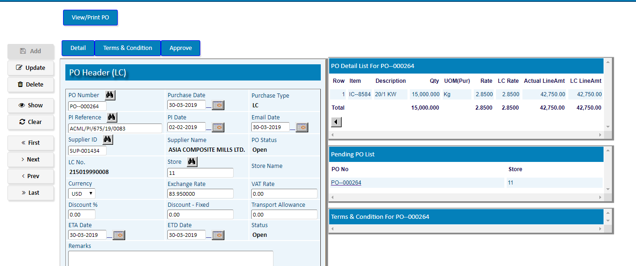

* Purchase Order Detail

(Now Click **Detail** Button to add the products of PO)

|  |  |
| --- | --- |
| **Step 1** | Choose Item Code, Fabric Type, Fabric Color, Width, Composition, Qty, Unit Price etc. |
| **Step 2** | Click **Add** |
| **Step 3** | Repeat steps 1 & 2 to add multiple Items. |
| **Step 4** | Click **Complete** to return Header |

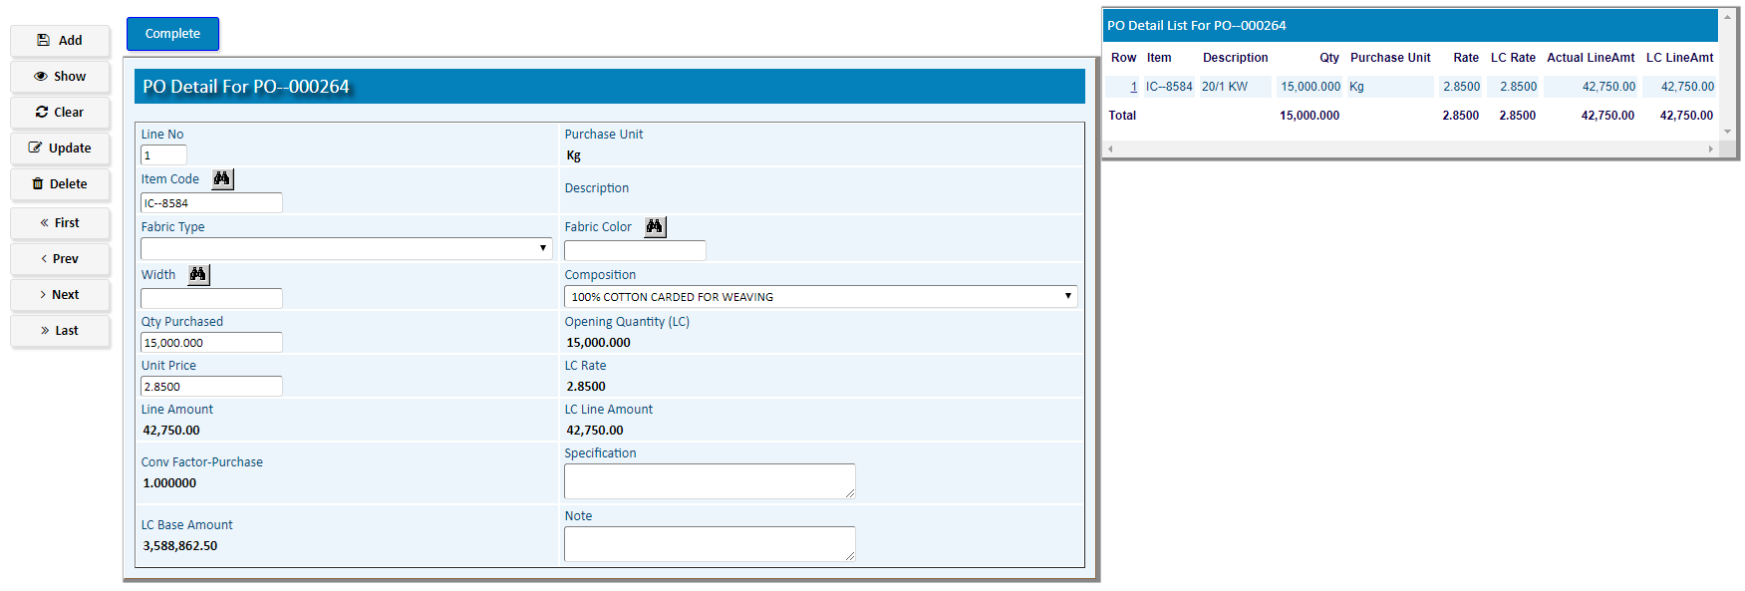

After Confirmation click **Approve** button to approve the PO

1. **Import LC Entry**

|  |  |
| --- | --- |
| **Step 1** | Main Menu (Home Icon) **> Commercial > Import LC >** Import LC Entry |
| **Step 2** | Write LC No., LC Type, Date, Supplier ID , Expiry Date |
| **Step 3** | Choose Currency, Exchange Rate, Margin, Freight Cost etc. |
| **Step 3** | Write PI Ref. No. , PI Date, Open Bank & Advising Bank |
| **Step 4** | Click **Add** |
| **Result** | A new LC added for the Supplier |

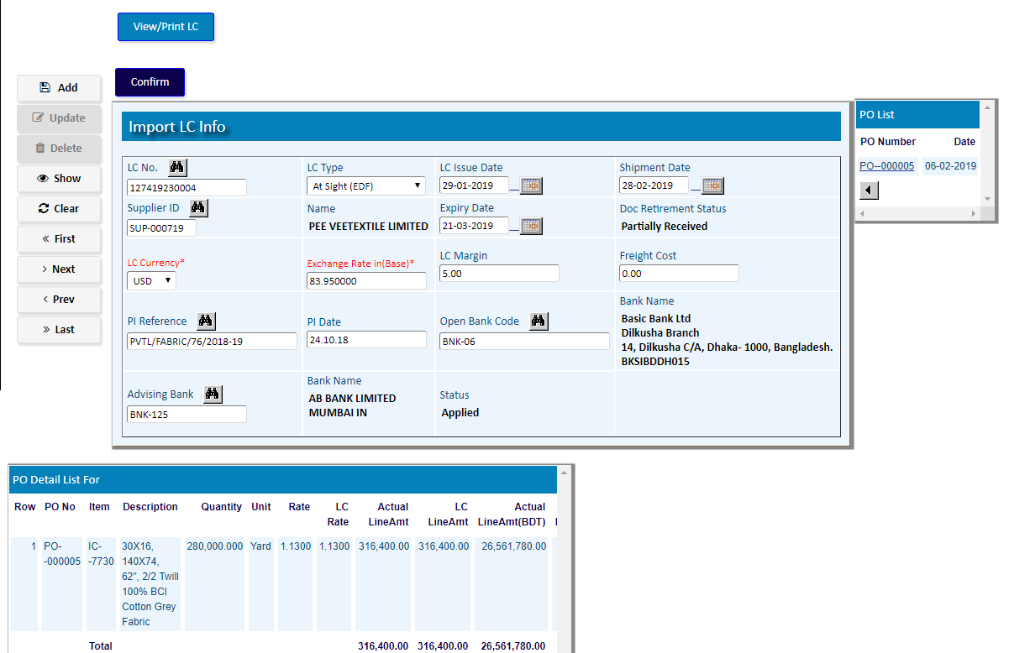

1. **PO link with LC**

**(To Make Link PO with the LC)**

|  |  |
| --- | --- |
| **Step 1** | Main Menu (Home Icon) **> Commercial > Import LC >**  PO LINK WITH LC |
| **Step 2** | Pick A Pending PO Number From the side list, Write LC No. |
| **Step 3** | Choose Currency, Exchange Rate, Remarks |
| **Step 4** | Click **Update** |
| **Result** | The PO will be linked with the Selected LC |

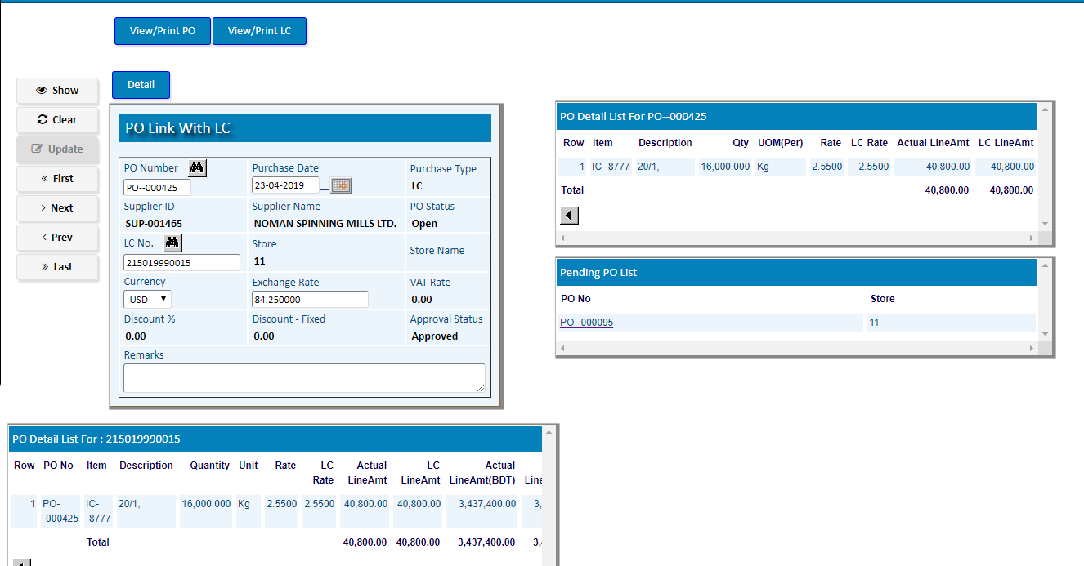

* 1. Click **Detail** Button
  2. Pick An **Item Code** From the PO Detail list
  3. **Update** Qty & Purchase Rate if required.
  4. Repeat b & c for more Items
  5. Click **Complete** after confirmation

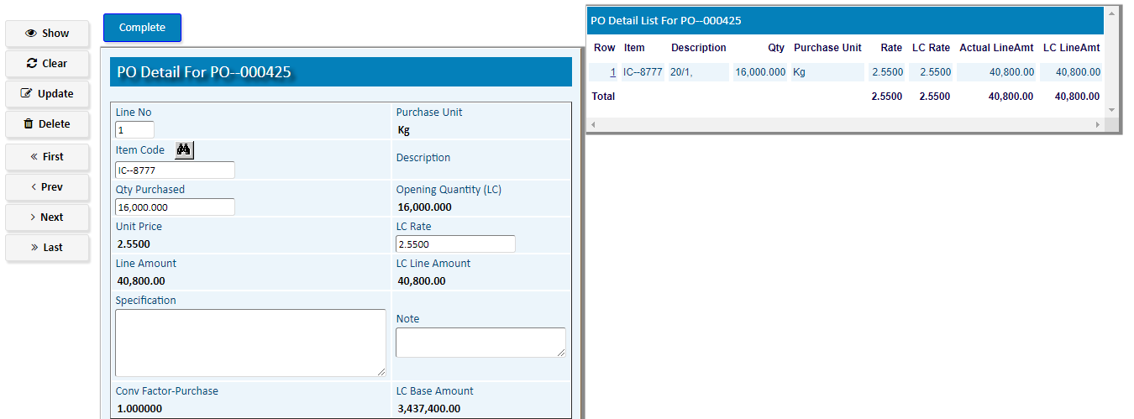

1. **Document Retirement**

|  |  |
| --- | --- |
| **Step 1** | Main Menu (Home Icon) **> Commercial > Import LC >**  DOCUMENT RETIREMENT |
| **Step 3** | Choose LC Number & Document/Invoice No. |
| **Step 3** | Choose **Store**, Currency, Exchange Rate, Freight Cost etc. |
| **Step 4** | Click **Add** |
| **Result** | The DOCUMENT RETIREMENT will be Added |

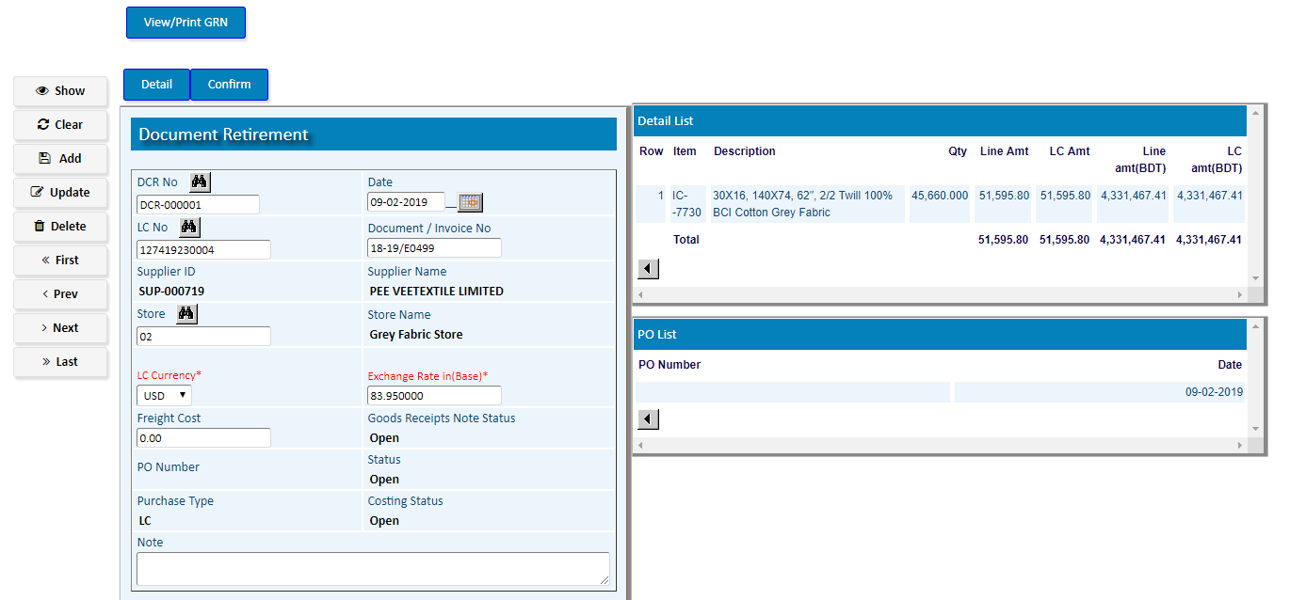

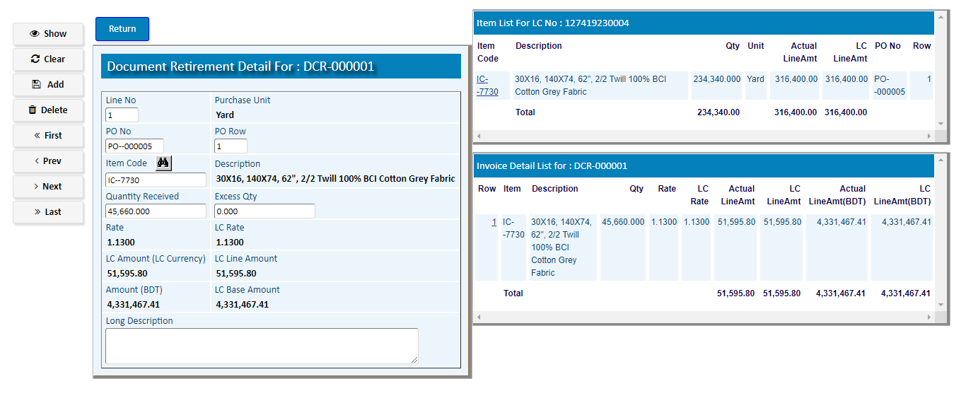

1. Click **Detail** Button
2. Pick An **Item Code** From the PO Detail list
3. Update Qty & Purchase Rate if required.

Click **Return** to Back DOCUMENT RETIREMENT header

Click **Confirm** top Confirm the DOCUMENT RETIREMENT

**Accounts Part**

1. **LC Opening Cost Entry**

|  |  |
| --- | --- |
| **Step 1** | Main Menu (Home Icon) **> Financial Accounts> LC Costing>**  LC OPENING COST ENTRY |
| **Step 2** | Pick A LC Number From the side list. |
| **Step 3** | Choose Currency, Exchange Rate, LC Margin |
| **Step 4** | Click **Update** |

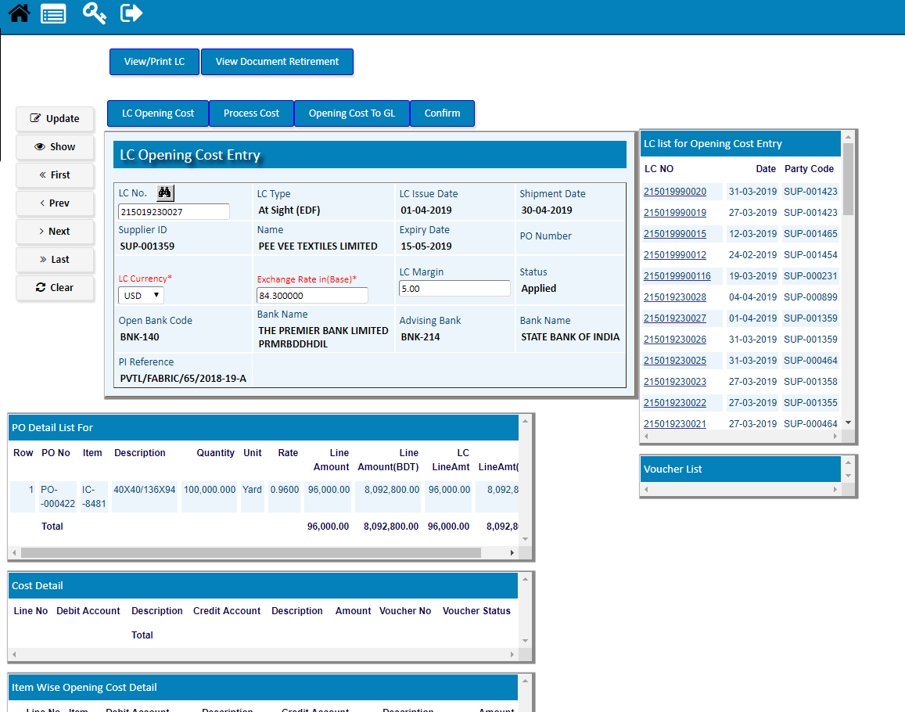

1. Click on **LC Opening Cost** button
2. Select a Debit Account & Credit Account
3. Fix the Debit Amount and Click **Add**

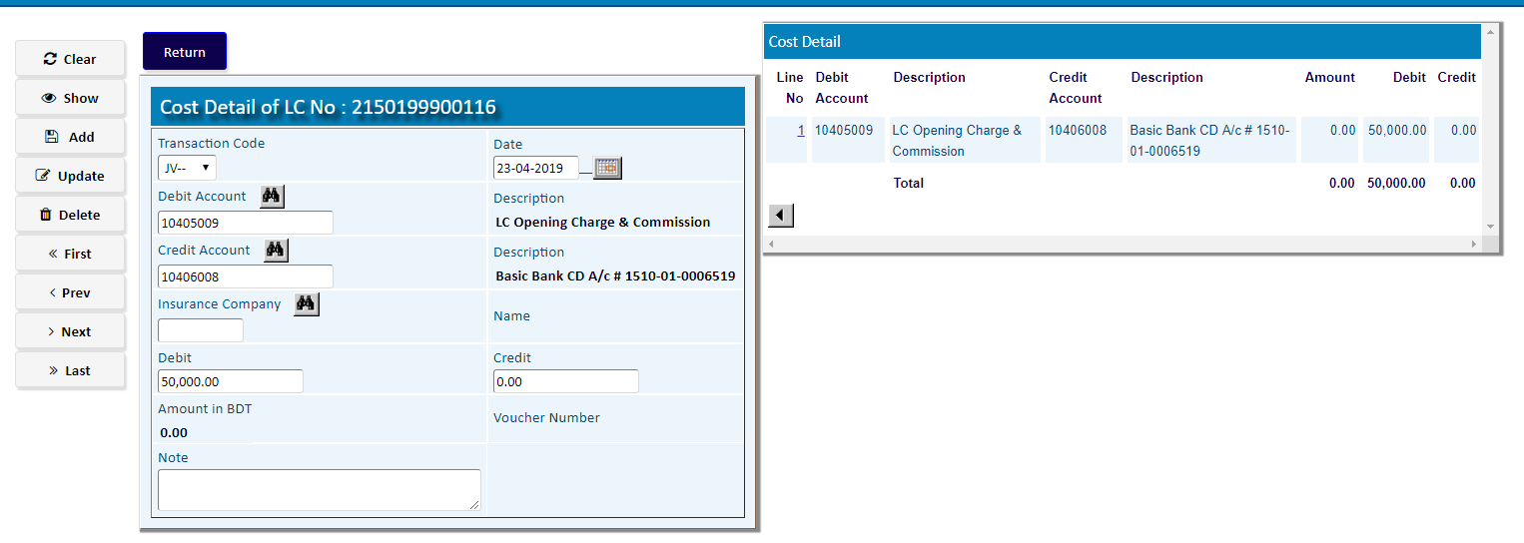

* After Completing Cost Entry, Click **Return** button and follow the steps :

1. Click **Process Cost** to process the LC Cost
2. Click **Opening Cost To GL** to transfer the LC Cost to GL
3. Click **Confirm** for confirmation of the LC Cost

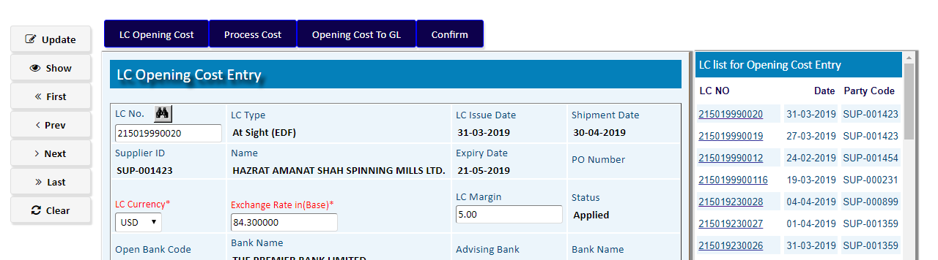

1. **Cost Payment & Payable Entry**

|  |  |
| --- | --- |
| **Step 1** | Main Menu (Home Icon) **> Financial Accounts> LC Costing >**  COST PAYMENT & PAYABLE ENTRY |
| **Step 2** | Pick A DCR Number From the side list. |
| **Step 3** | Choose A Date, LTR Pay to, LC Acc. , Margin, LC currency, Other Currency |
| **Step 4** | Write Invoice Number & Click **Update** |
| **Result** | The DCR will be updated by date, Accounts & Currency |

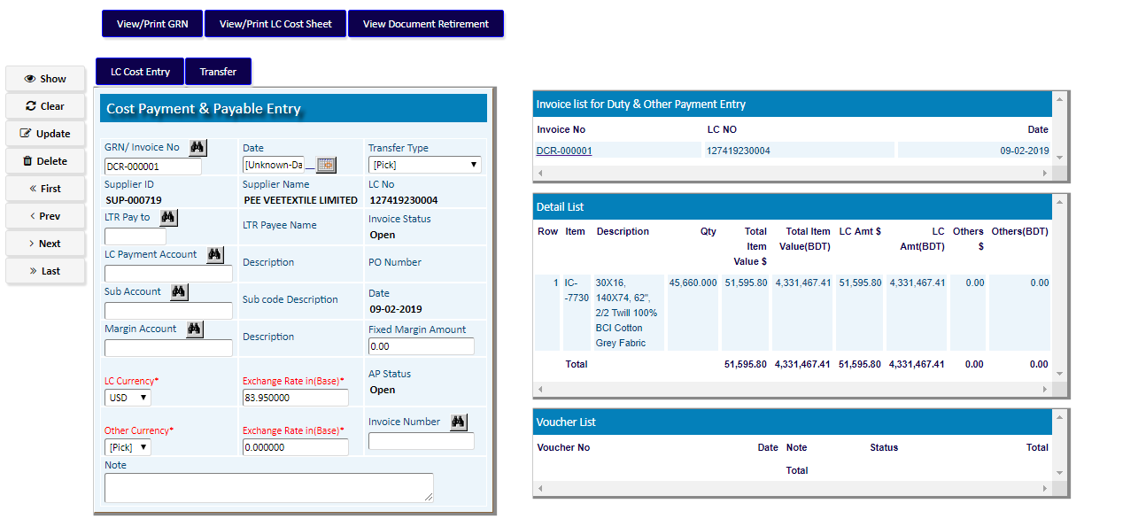

1. Click **LC Cost Entry** Button
2. Select A Taransaction CodeChoose the Debit/Credit Account & Amount In BDT
3. Click Add
4. Repeat the steps b & c to add multiple cost

Click **Return**

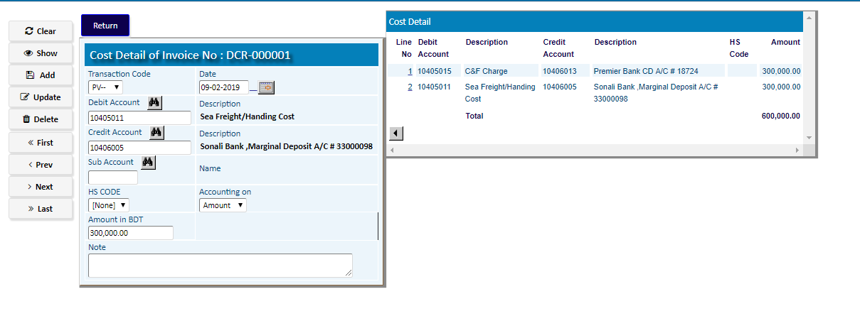

**(Follow the steps of Transfer Type to Tranfer COST)**

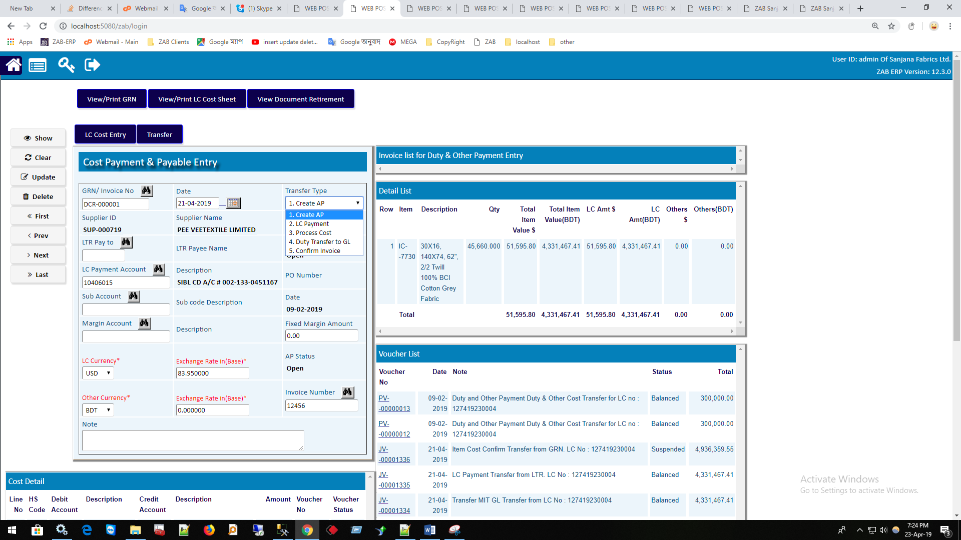

**Creatye AP** (To create a new Accounts Payable Voucher)

Select **Create AP** from the **Transfer Type** and click on **Transfer** button

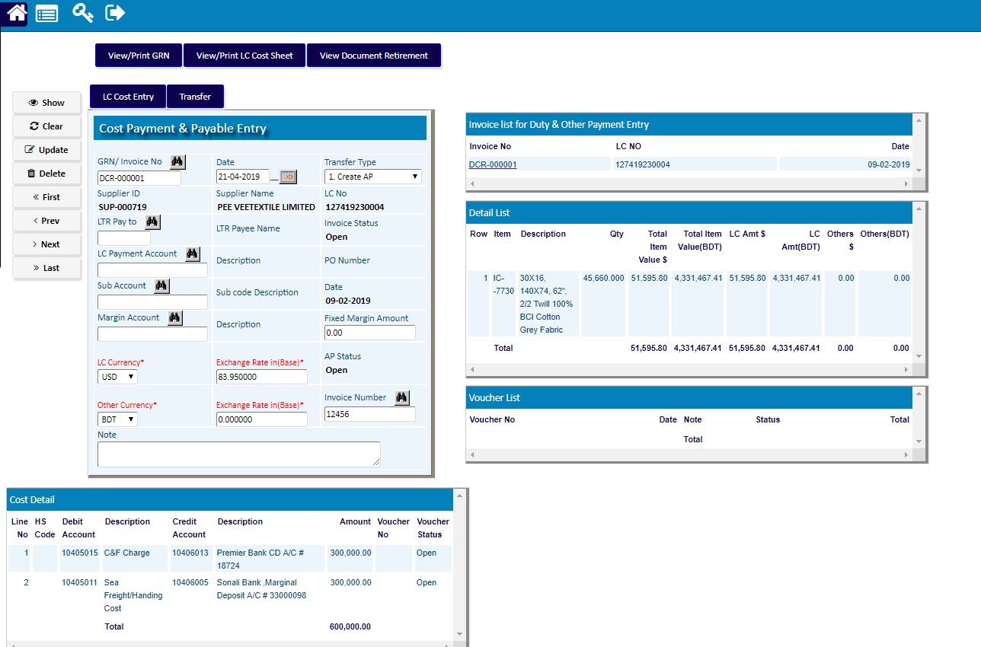

**LC PAyment** (To create a new Payment of LC)

Select **LC Payment** from the **transfer type** and click on **Transfer** button

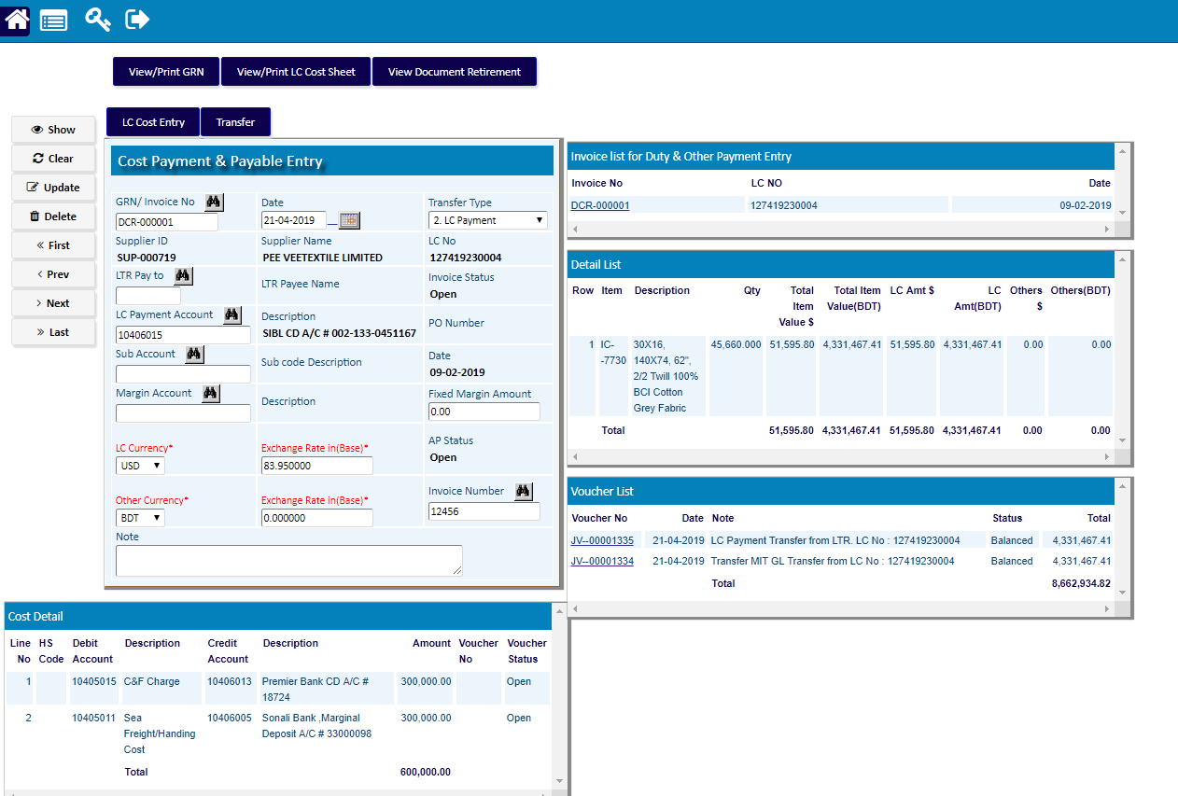

**Process Cost** (To Process LC cost)

Select **Process Cost** from the **transfer type** and click on **Transfer** button

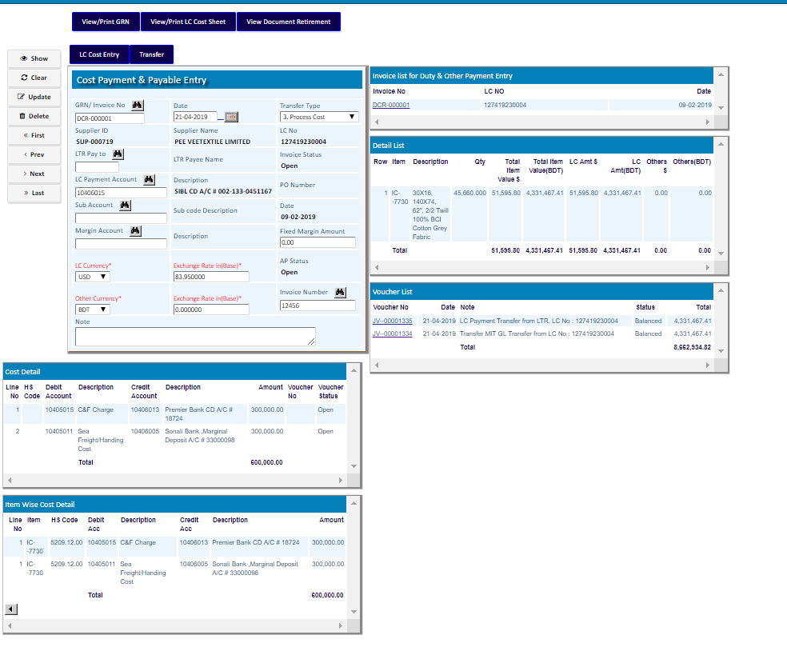

**Transfer To GL** (To transfer LC cost to GL)

Select **Duty Transfer to GL** from the **transfer type** and click on **Transfer** button

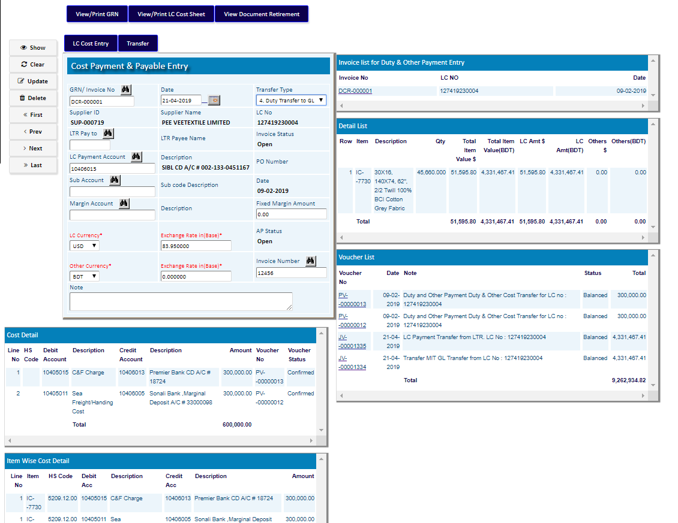

**Confirm Invoice** (To Confirm)

Select **Confirm Invoice** from the **transfer type** and click on **Transfer** button

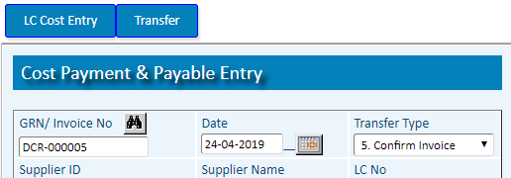

**Inventory Part**

1. [**Create GRN From DCR (LC)**](http://175.29.187.148:8080/zab/login?screen=pogrnheadergrn&option=Create+GRN+From+DCR+%28LC%29&menuname=im)

|  |  |
| --- | --- |
| **Step 1** | Main Menu (Home Icon) **> Inventory Management > Create GRN From DCR (LC)** |
| **Step 2** | Choose A DCR Number |
| **Step 3** | Click **Create GRN** button to create GRN from the DCR |
| **Result** | A new GRN will be created from the DCR and will show on the side list |

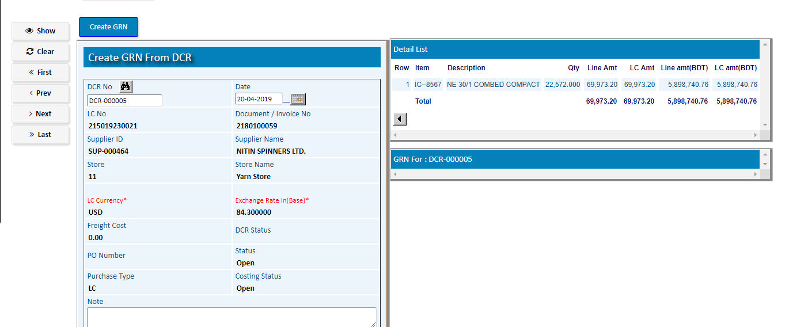

Click on the created **GRN Number** of the side list to **confirm** the GRN

1. [**GRN Confirm (LC)**](http://175.29.187.148:8080/zab/login?screen=pogrnim&option=GRN+Confirm+%28LC%29&menuname=im)

|  |  |
| --- | --- |
| **Step 1** | Main Menu (Home Icon) **> Inventory Management > GRN CONFIRM (LC)** |
| **Step 2** | Choose the GRN Number & Click **Show** |
| **Step 3** | Click on **Detail** button to add GRN items |

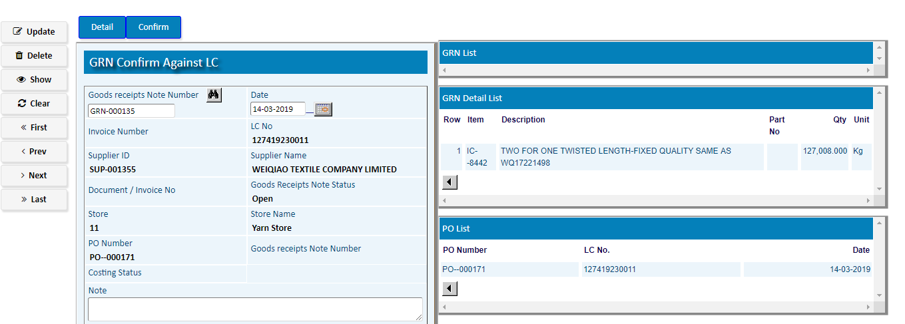

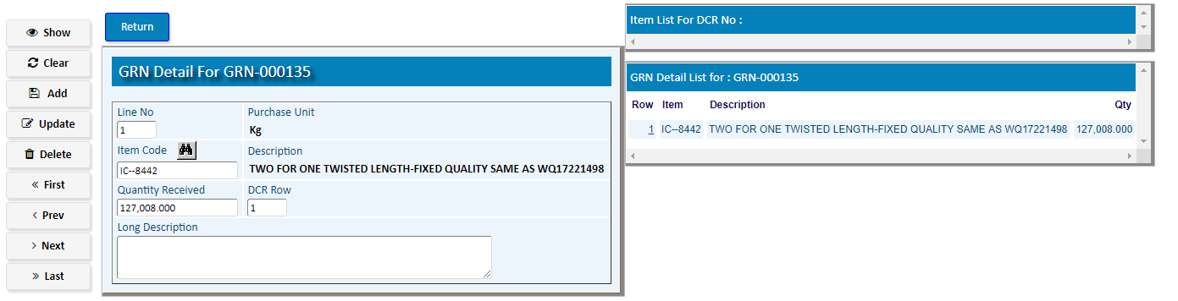

1. Pick a Item for the DCR Item list.
2. Update Quantity Received
3. Repeat a & b for multiple Items
4. After adding Items for GRN, Click **Return** Button
5. Click on **Confirm** Button to Confirm the GRN